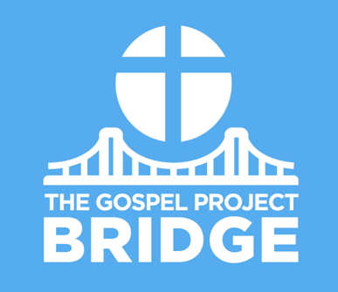
Parent Connect

March 12, 2021
The Last Supper

Dear Parents,

As the Passover celebration drew near, Jerusalem hummed with excitement. Everyone wondered if Jesus—teacher, miracle-worker, and prophet—would come for Passover. (John 11:56-57) The Passover meal was a permanent statute God intended for every Israelite family to observe each year. (See Ex. 12:1-28; Lev. 23:5-8.) But it was no secret the religious leaders were determined to kill Jesus. Jesus had warned His disciples what would happen this Passover. (Mark 10:33-34; Luke 18:31)

As they ate the Passover meal, Jesus broke bread and gave it to His disciples. He shared the cup with them too, explaining that the bread and cup represented His body and blood. Jesus established a new covenant.

In the Old Testament, God made a covenant, or promise, with His people. He gave them commandments to follow so they could live in right relationship with Him. But God’s people broke the covenant. They didn’t obey God, and they didn’t love Him.

What the sacrifice of the Passover lamb could not do—take away sins once and for all—the perfect Lamb of God was going to do. Jesus, the perfectly sinless Son of God, was going to take the punishment for sin upon Himself. (See Heb. 10:1-10.) As Jesus’ disciples prepared for Passover, Jesus prepared to die. By dying on the cross, Jesus brought forgiveness and made the way for people to know and love God again.

Jesus showed His disciples with the bread and the drink that He is the true Passover Lamb. God’s people had broken the old covenant, and God promised to make a new covenant to forgive sins. The new covenant says that everyone who turns away from sin and trusts in Jesus’ death and resurrection will be forgiven of his sins and will have eternal life.

Believers take the Lord’s Supper to remember what Jesus did for us in His death and resurrection. We remember God’s faithfulness, and we look forward to the day that Jesus will return.

If your kids are not ready to take the Lord’s Supper at church, gently explain that the Lord's Supper, like baptism, is an ordinance of the church and is a celebration for those who have repented of their sin and trusted in Jesus for salvation.

FAMILY STARTING POINTS

Babies and Toddlers
- Jesus ate a special meal with His friends.
- Jesus told His friends about God’s plan.
- Jesus told His friends to remember what He did for them.
- Jesus made a new, better promise.
- Jesus died to rescue us.

Preschool
- Jesus told His disciples to remember Him.
- What did Jesus do to save us? Jesus died on the cross and rose from the dead.

Kids
- Jesus commanded His disciples to remember His sacrifice.
- What did Jesus do to save us? Jesus lived a sinless life, died on the cross, and rose from the dead.

UNIT KEY PASSAGE

Philippians 2:8

