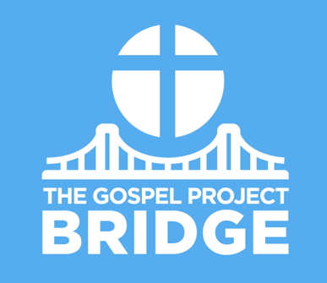
Parent Connect

March 26, 2021
Jesus’ Crucifixion

Dear Parents,

Jesus’ crucifixion, burial, and resurrection are the center of the gospel. Jesus accomplished the plan God had been working out throughout the Old Testament to bring salvation to sinners, and it happened in such an unlikely way.

In the Book of Acts, Peter testified to the Israelites about Jesus’ death: “Though He was delivered up according to God’s determined plan and foreknowledge, you used lawless people to nail Him to a cross and kill Him” (Acts 2:23). Crucifixion was a horrific way to die. As you teach kids, rather than focus on the graphic details of how Jesus died, emphasize why He died. Two primary reasons stand out: God is loving, and God is just.

First, God is loving. He sent His Son to be the Savior of the world because He loves us. (See John 3:16; Rom. 5:8; 1 John 4:10.) Jesus submitted to the Father’s will; He humbled Himself and came to earth as a man, and He laid down His life because He loves us. (Eph. 5:2)

Jesus lived the perfect life we failed to live and died the guilty death we don’t want to die. Those who trust in Him receive forgiveness and eternal life.

Second, God is just. God’s law for the people was plain. (See Deuteronomy 6:5.) But God’s people, and all people, broke the law. We have loved other things more than we love God. That is sin. So why did Jesus have to die? Why couldn’t He just say, “You are forgiven”? Because God is just, He requires due payment for sin. To simply forgive sin
without requiring a payment would be unjust.

Jesus was our substitute, taking our place on the cross and absorbing God’s wrath on our behalf so we can be forgiven and declared righteous. (See Rom. 3:25-26; Col. 2:13-15.) Jesus died to rescue sinners from slavery to sin, and when we trust in Him, we are free indeed.

We deserve to die because of our sins, but God loves us and kept His promise to send a Savior. Jesus never sinned, but He died in our place. He was the blood sacrifice made once and for all for the forgiveness of sin. Jesus rose from the dead on the third day, and those who trust in Him have forgiveness and eternal life.

FAMILY STARTING POINTS

Babies and Toddlers
- Jesus never did anything wrong.
- Jesus died on the cross to do God’s plan.
- God made Jesus alive again.
- We deserve to die because of sin, but Jesus died for us.
- Jesus died to rescue us.

Preschool
- Jesus died on the cross for our sin.
- What did Jesus do to save us? Jesus died on the cross and rose from the dead.

Kids
- Jesus died on the cross to pay for our sins.
- What did Jesus do to save us? Jesus lived a sinless life, died on the cross, and rose from the dead.

UNIT KEY PASSAGE

Philippians 2:8

