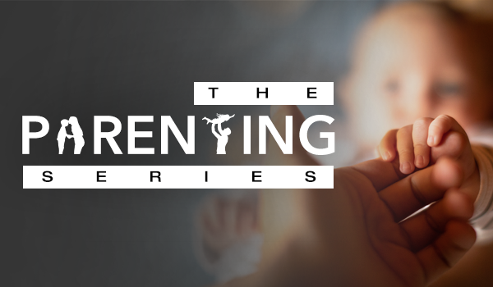

The Self-Controlled Child
By Dr. James Dobson

But the fruit of the Spirit is ... self-control. (Galatians 5:22-23)
Many parents take a passive approach to guiding and disciplining their children because they want their kids to learn self-control. But since young people lack the maturity to generate self-discipline, the good intentions of these parents usually fail. Their kids enter adulthood without ever having learned how to manage their own lives or control their own impulses.

Consider the example of Doug, a young man who has never learned to curb his temper or his tongue. His parents consistently ignored their son's angry outbursts during childhood, assuming he would eventually learn to control this problem on his own. Years later, Doug lands his first full-time job, but quickly gets into a heated dispute with his boss and is fired. It is only the first of many disappointments ahead.

Your children need help in developing self-discipline and self-control. Allow them, within reason, to suffer the unpleasant consequences of their mistakes, such as walking to school when they miss the bus or paying for the repairs when they put a dent in the family car. Most important, encourage them to spend time in the Word of God and to invite Jesus

into their hearts. When they give their lives to Him, they will begin to enjoy the fruits of the indwelling Holy Spirit (Galatians 5:22)–including self-control.

Just between us...
- Are you allowing your kids to experience the consequences of their actions?
- In what new ways could you help your children develop self-control?

Pray these words together:
Father, help us to stand firm when we feel weak, to remain steady when we'd rather shrug our shoulders, and to lead our children with patience and wisdom. Let us be good examples ourselves as we seek to develop self- control in our kids. Amen.

From Dr. James Dobson’s book Night Light for Parents

