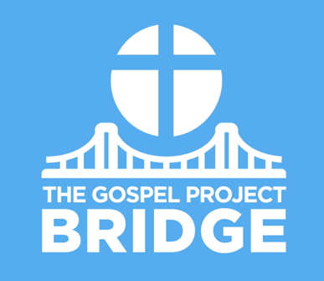
Parent Connect

March 5, 2021
Jesus’ Triumphal Entry

Dear Parents,

Leading into the last week of Jesus’ ministry before His death and resurrection, Jesus entered Jerusalem as the King of kings. Many of God’s people traveled to Jerusalem for Passover. Jesus and His disciples traveled to Jerusalem as well. Near Bethphage (BETH fayj) and Bethany near the Mount of Olives, Jesus sent two disciples ahead into a village.

Jesus told them, “You will find a young donkey tied there. No one has ever sat on it. Untie it and bring it here. If anyone says to you ‘Why are you doing this?’ say, ‘The Lord needs it.’” Jesus would fulfill Zechariah’s prophecy: “Look, your King is coming to you … humble and riding on a donkey” (Zech. 9:9).

Jesus made a spectacular entrance into the city. He rode a donkey, and people laid branches and their robes on the ground in front of Him. The people welcoming Jesus into Jerusalem believed He was the promised Messiah, but they expected Him to overthrow Roman oppression and set up an earthly throne. Jesus sent a different message.

The next day, Jesus entered the temple and turned over the tables of the money changers and those selling doves. Jesus referred to Isaiah 56:7, declaring that His kingship would not just be over the Jews but over all people. While Jesus was in the temple, He healed the blind and the lame. Jesus’ actions declared, “I am not just your King; I am also your God.” (See Isa. 35:4-6.)

Finally, the priests and the scribes heard the children in the temple worshiping Jesus as their King. “Do You hear what these children are saying?” they asked. Jesus replied, quoting Psalm 8:2. Jesus gladly received their praise because He was worthy of their praise. Jesus is the Son of God who came to overthrow sin and set up an eternal throne.

During Jesus’ triumphal entry, the people welcomed Him as King. Jesus was the Messiah spoken about by the prophet Zechariah: “Look, your King is coming to you; He is righteous and victorious, humble and riding on a donkey, on a colt, the foal of a donkey” (Zechariah 9:9). One day, Jesus will return to earth on a white horse as King over everything.

Help your kids connect the dots between God’s promises of a Messiah and Jesus’ coming. Help them understand why Jesus came: to save the world from sin!

FAMILY STARTING POINTS
Babies and Toddlers
- Jesus rode into Jerusalem on a donkey.
- People welcomed Jesus as their King.
- God sent Jesus to earth because He loves us.
- Jesus is the King who rescues His people.
- Jesus died to rescue us.

Preschool
- People welcomed Jesus as their King.
- What did Jesus do to save us? Jesus died on the cross and rose from the dead.

Kids
- People welcomed Jesus to Jerusalem as their King.
- What did Jesus do to save us? Jesus lived a sinless life, died on the cross, and rose from the dead.

UNIT KEY PASSAGE

Philippians 2:8

